D-311 Unit 2: Introduction to Law Enforcement

Objectives:
- Discuss Federal Law Enforcement missions and authorities.
- List six do’s and don’ts of call taking.
- Describe how to gather pertinent details for law enforcement incidents.
- Describe how you can support law enforcement officers during daily patrol and contacts.
- Discuss different law enforcement incident types and prioritization.
- List dispatcher duties during emergency law enforcement situations.
- Describe the steps to take in an officer down situation.
- Overview the components of the Criminal Justice Information (CJI).

Unit at a Glance:
Topics | Method | Duration
Law Enforcement Missions | Presentation | 10 Min
Call Taking | Presentation / Group Discussion | 20 Min
Gathering Pertinent Details | Presentation | 10 Min
Descriptive Information | Group Discussion | 15 Min
Daily Patrols | Presentation / Group Discussion | 15 Min
Contacts & Prioritizing | Presentation | 10 Min
Increased Risk Incidents | Presentation / Group Discussion | 15 Min
Status Checks | Presentation | 10 Min
Restricting Radio Traffic | Presentation | 10 Min
Exercise | Group Activity | 30 Min
Total Unit Duration |  | Total 3 Hrs

Course Materials:
Laptop/desktops
FAMAUTH and WildCAD Training access
Handheld Radio

Classroom:
- Ability to display images and video on large screen.
- Internet access

Slide 1
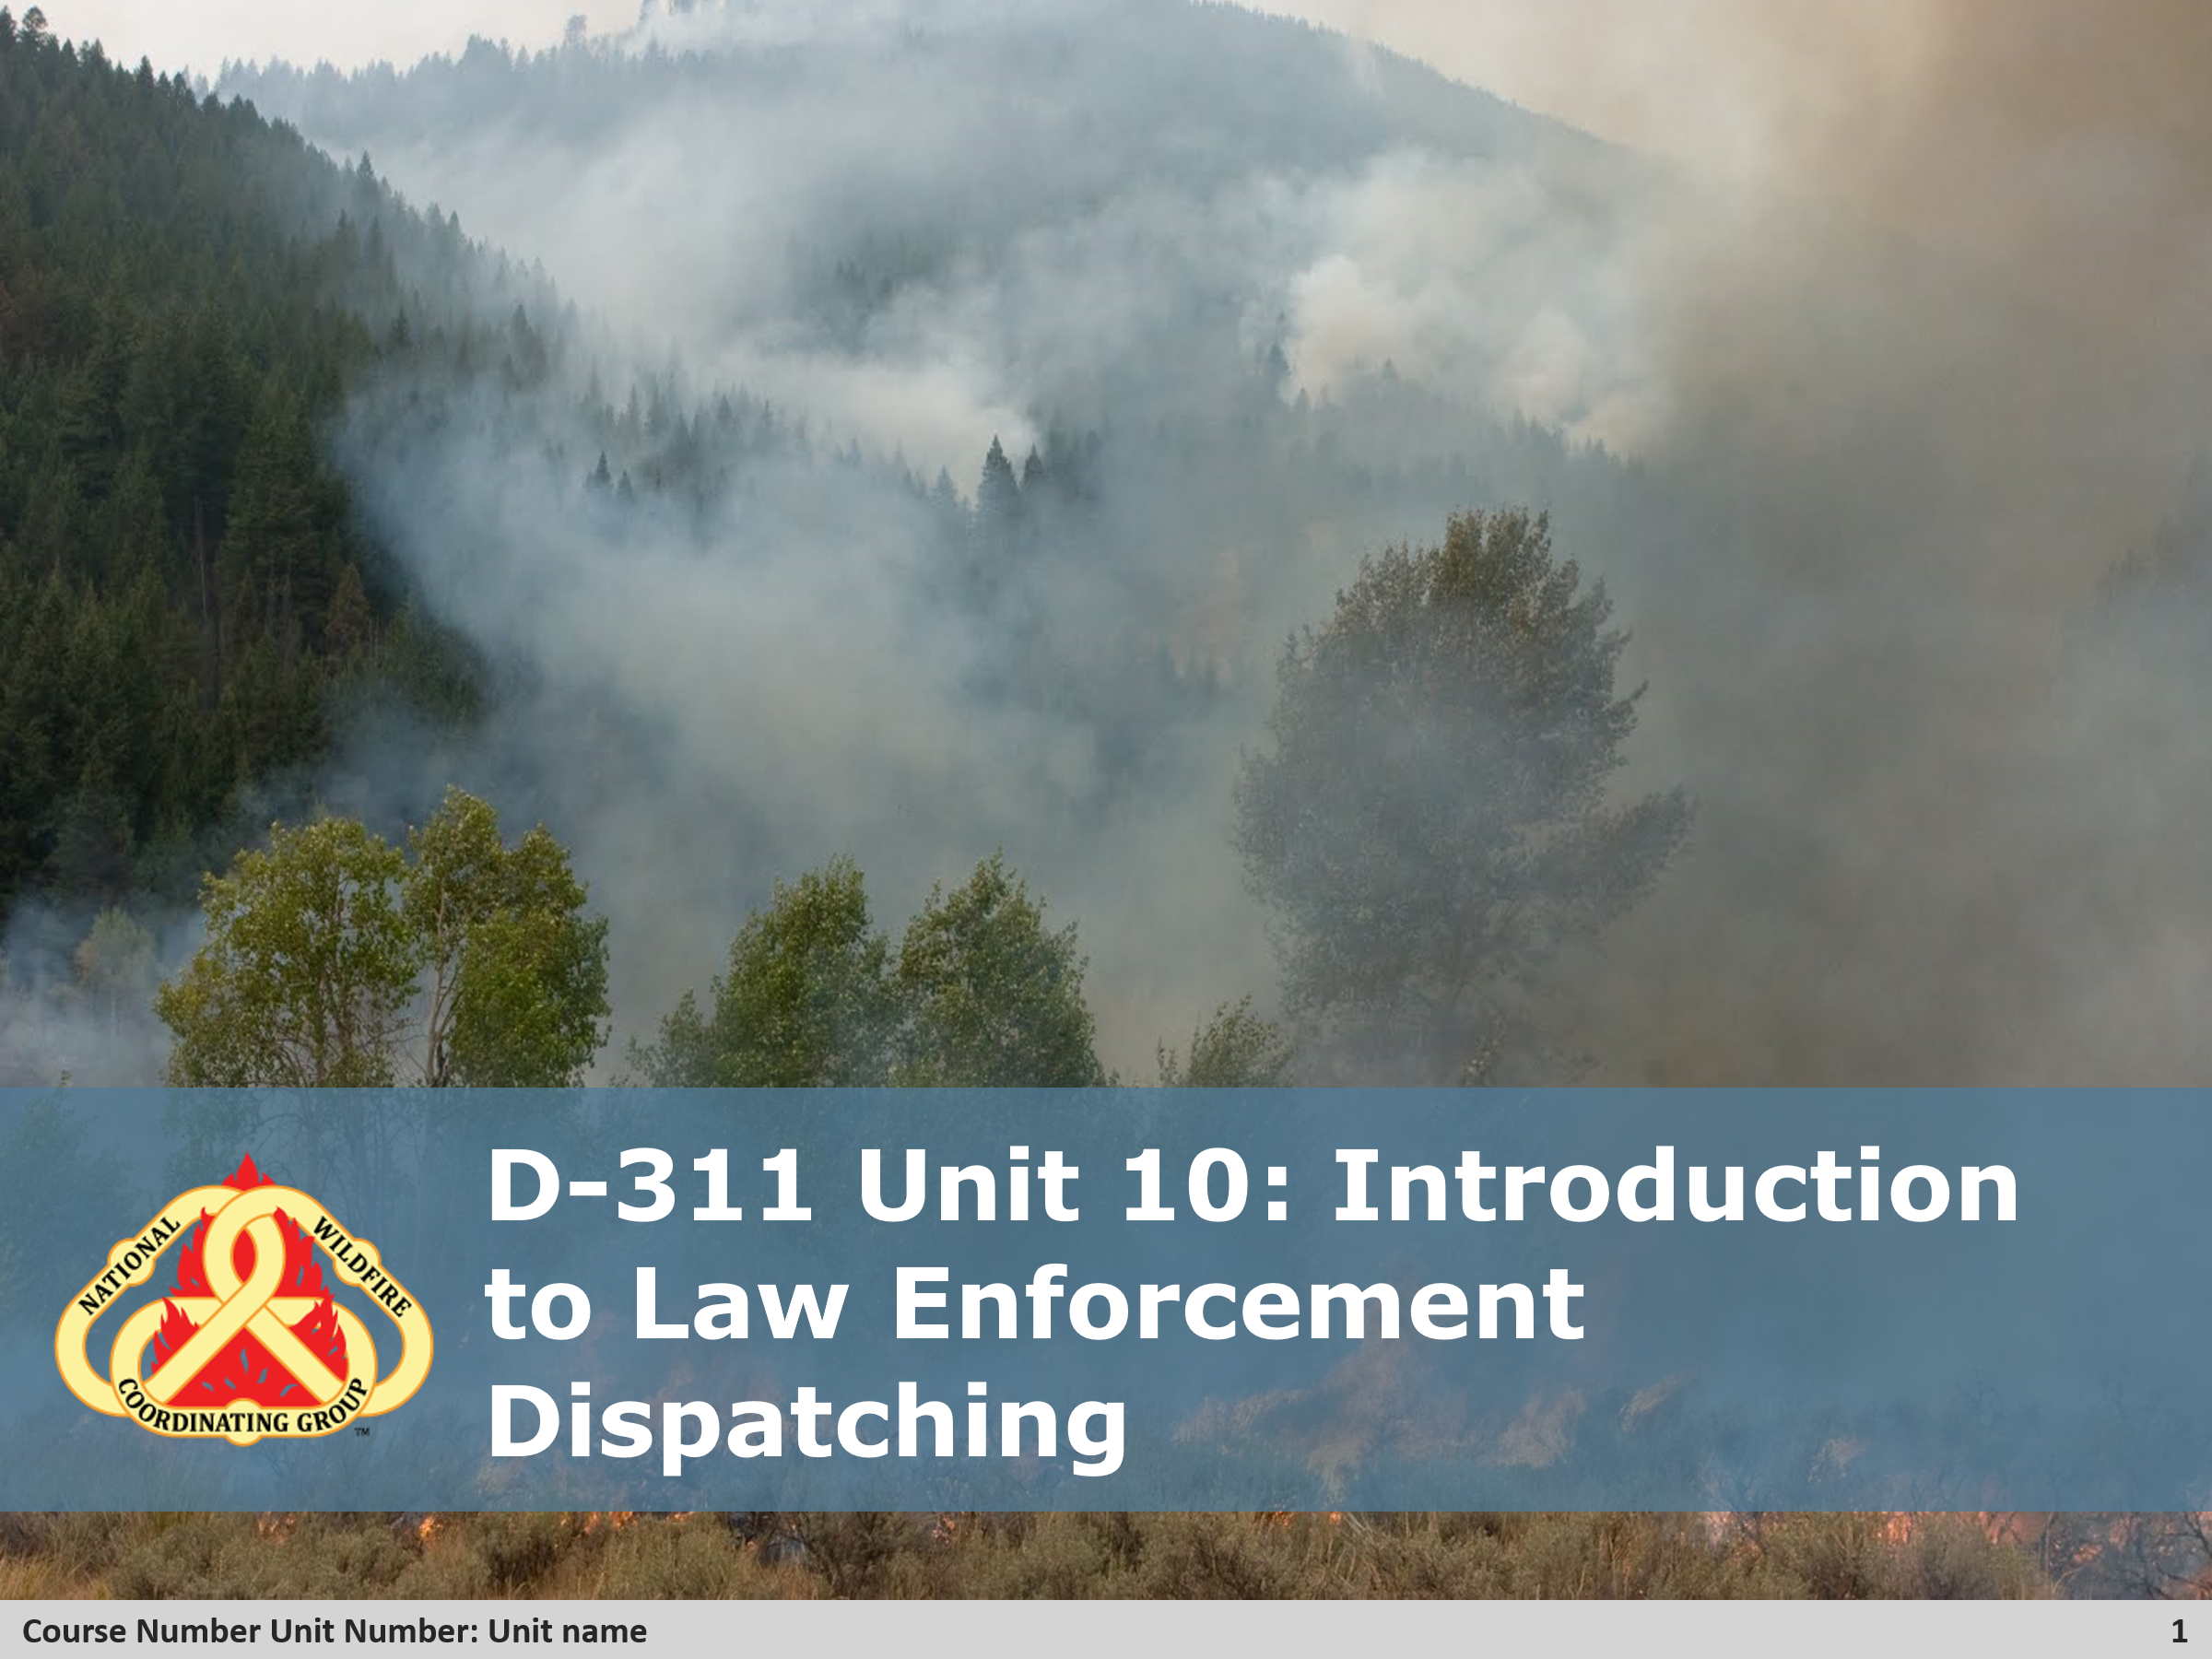

Slide 2 Objectives
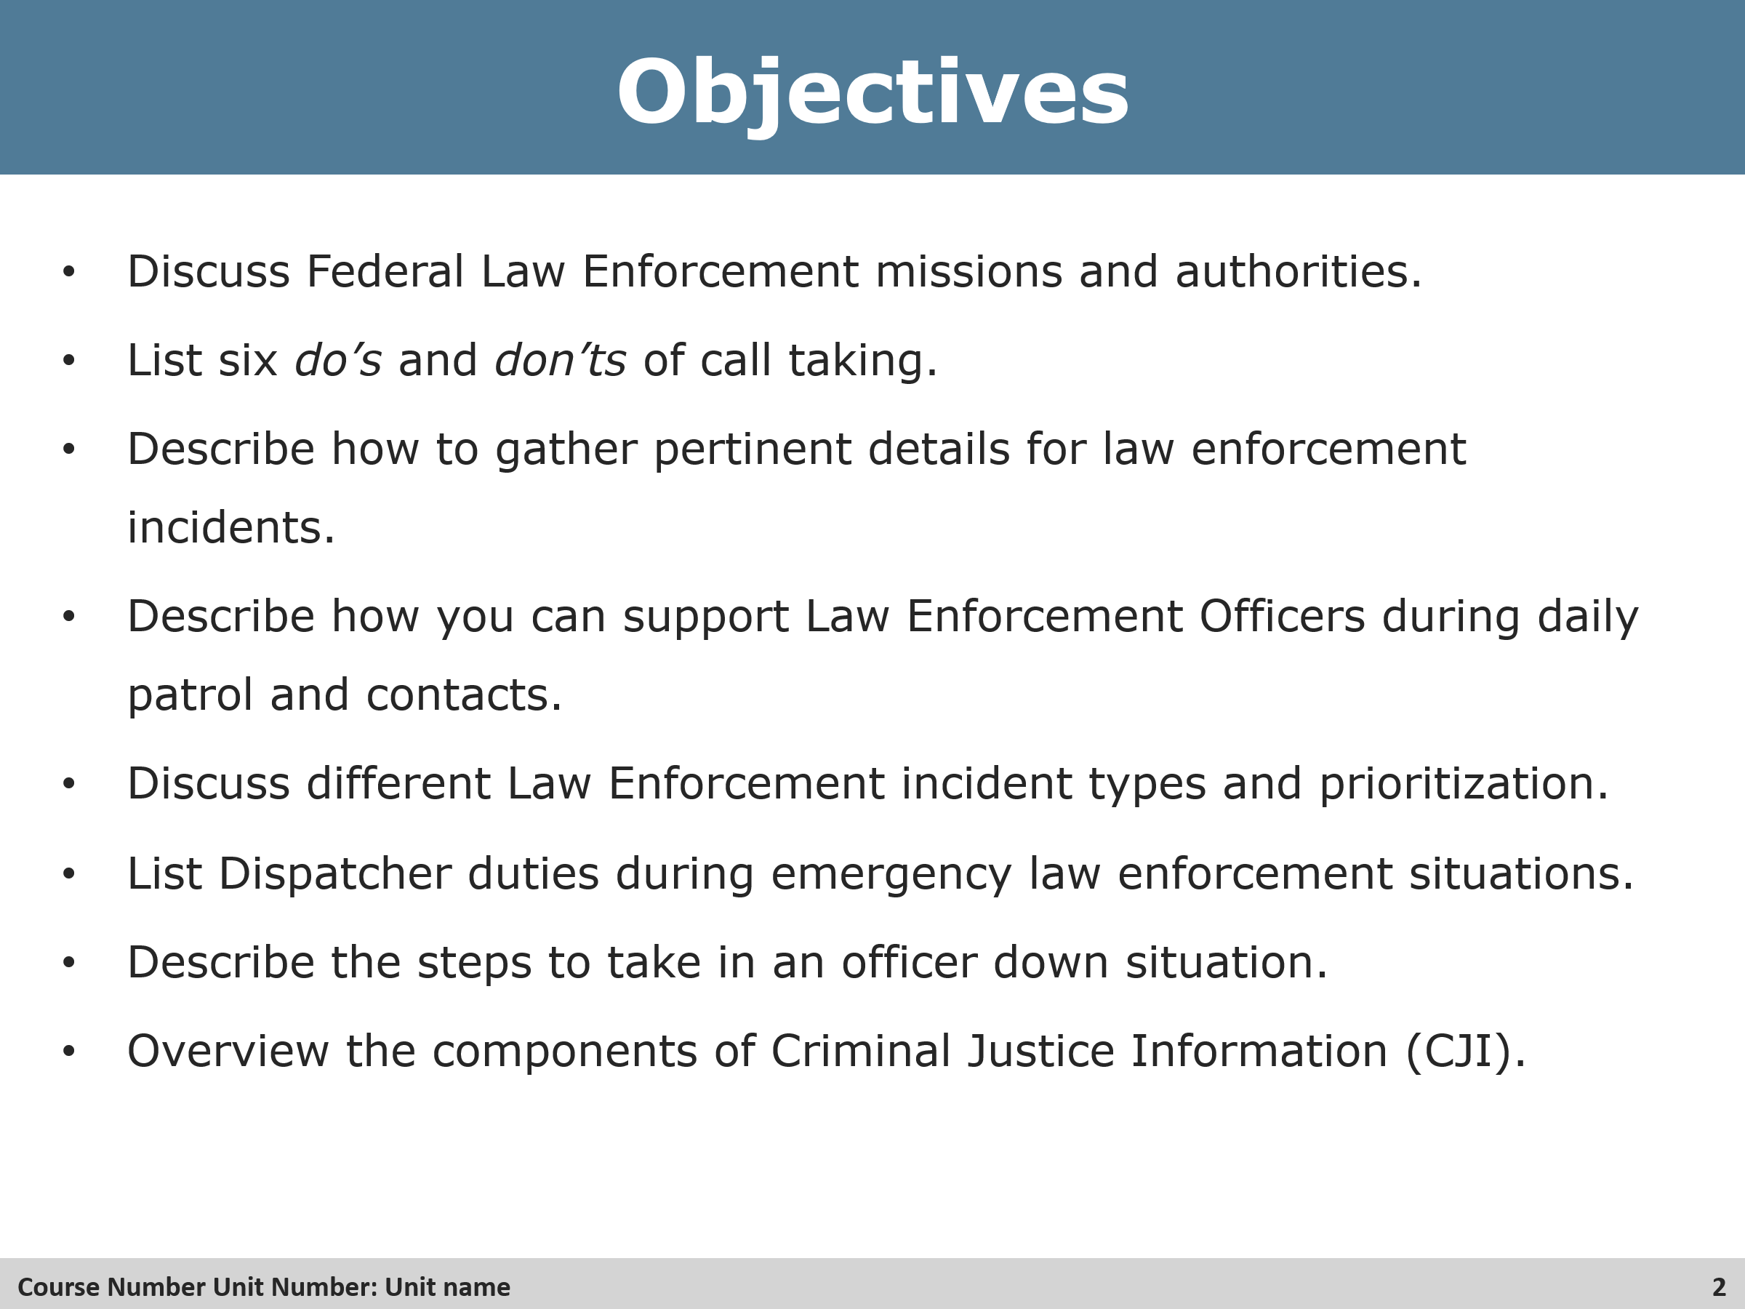
Review Unit Objectives
By the end of this unit students will be able to:
- Discuss Federal Law Enforcement missions and authorities.
- List six do’s and don’ts of call taking
- Describe how to gather pertinent details for law enforcement incidents.
- Describe how you can support Law Enforcement Officers during daily patrol and contacts.
- Discuss different Law Enforcement incident types and prioritization.
- List dispatcher duties during emergency law enforcement situations.
- Describe the steps to take in an officer down situation.
- Overview the components of Criminal Justice Information (CJI).

Slides 3 & 4 Law Enforcement Missions
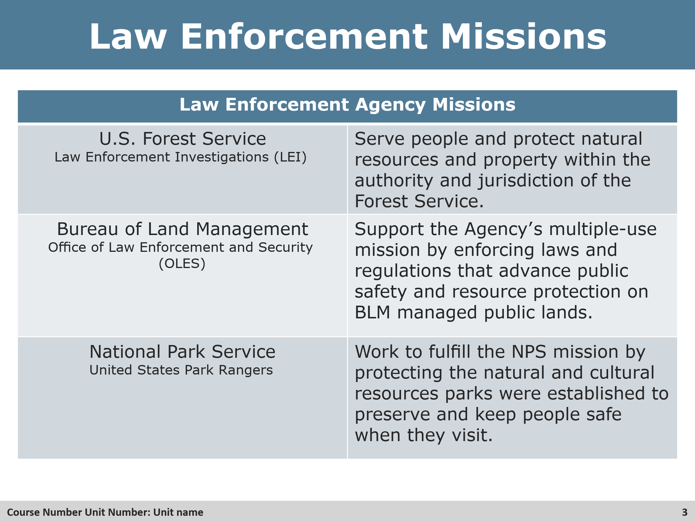

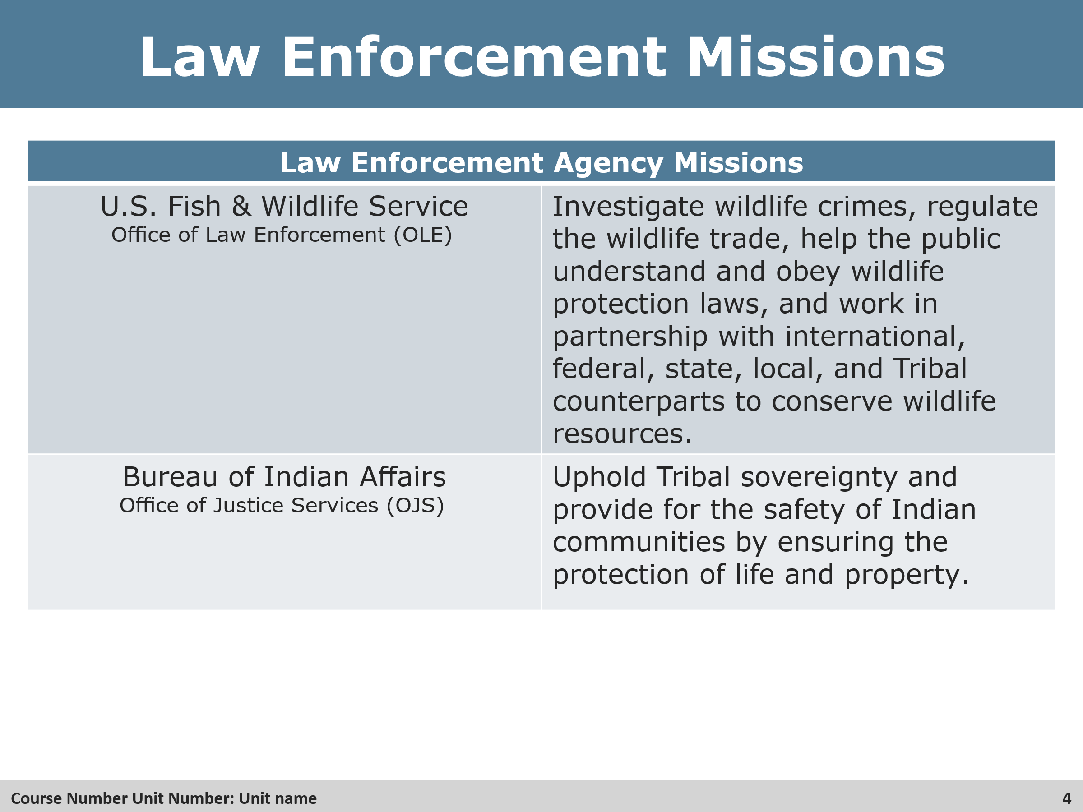
Review
- Review the federal law enforcement agencies and their missions with the students.

Slide 5 Call Taking
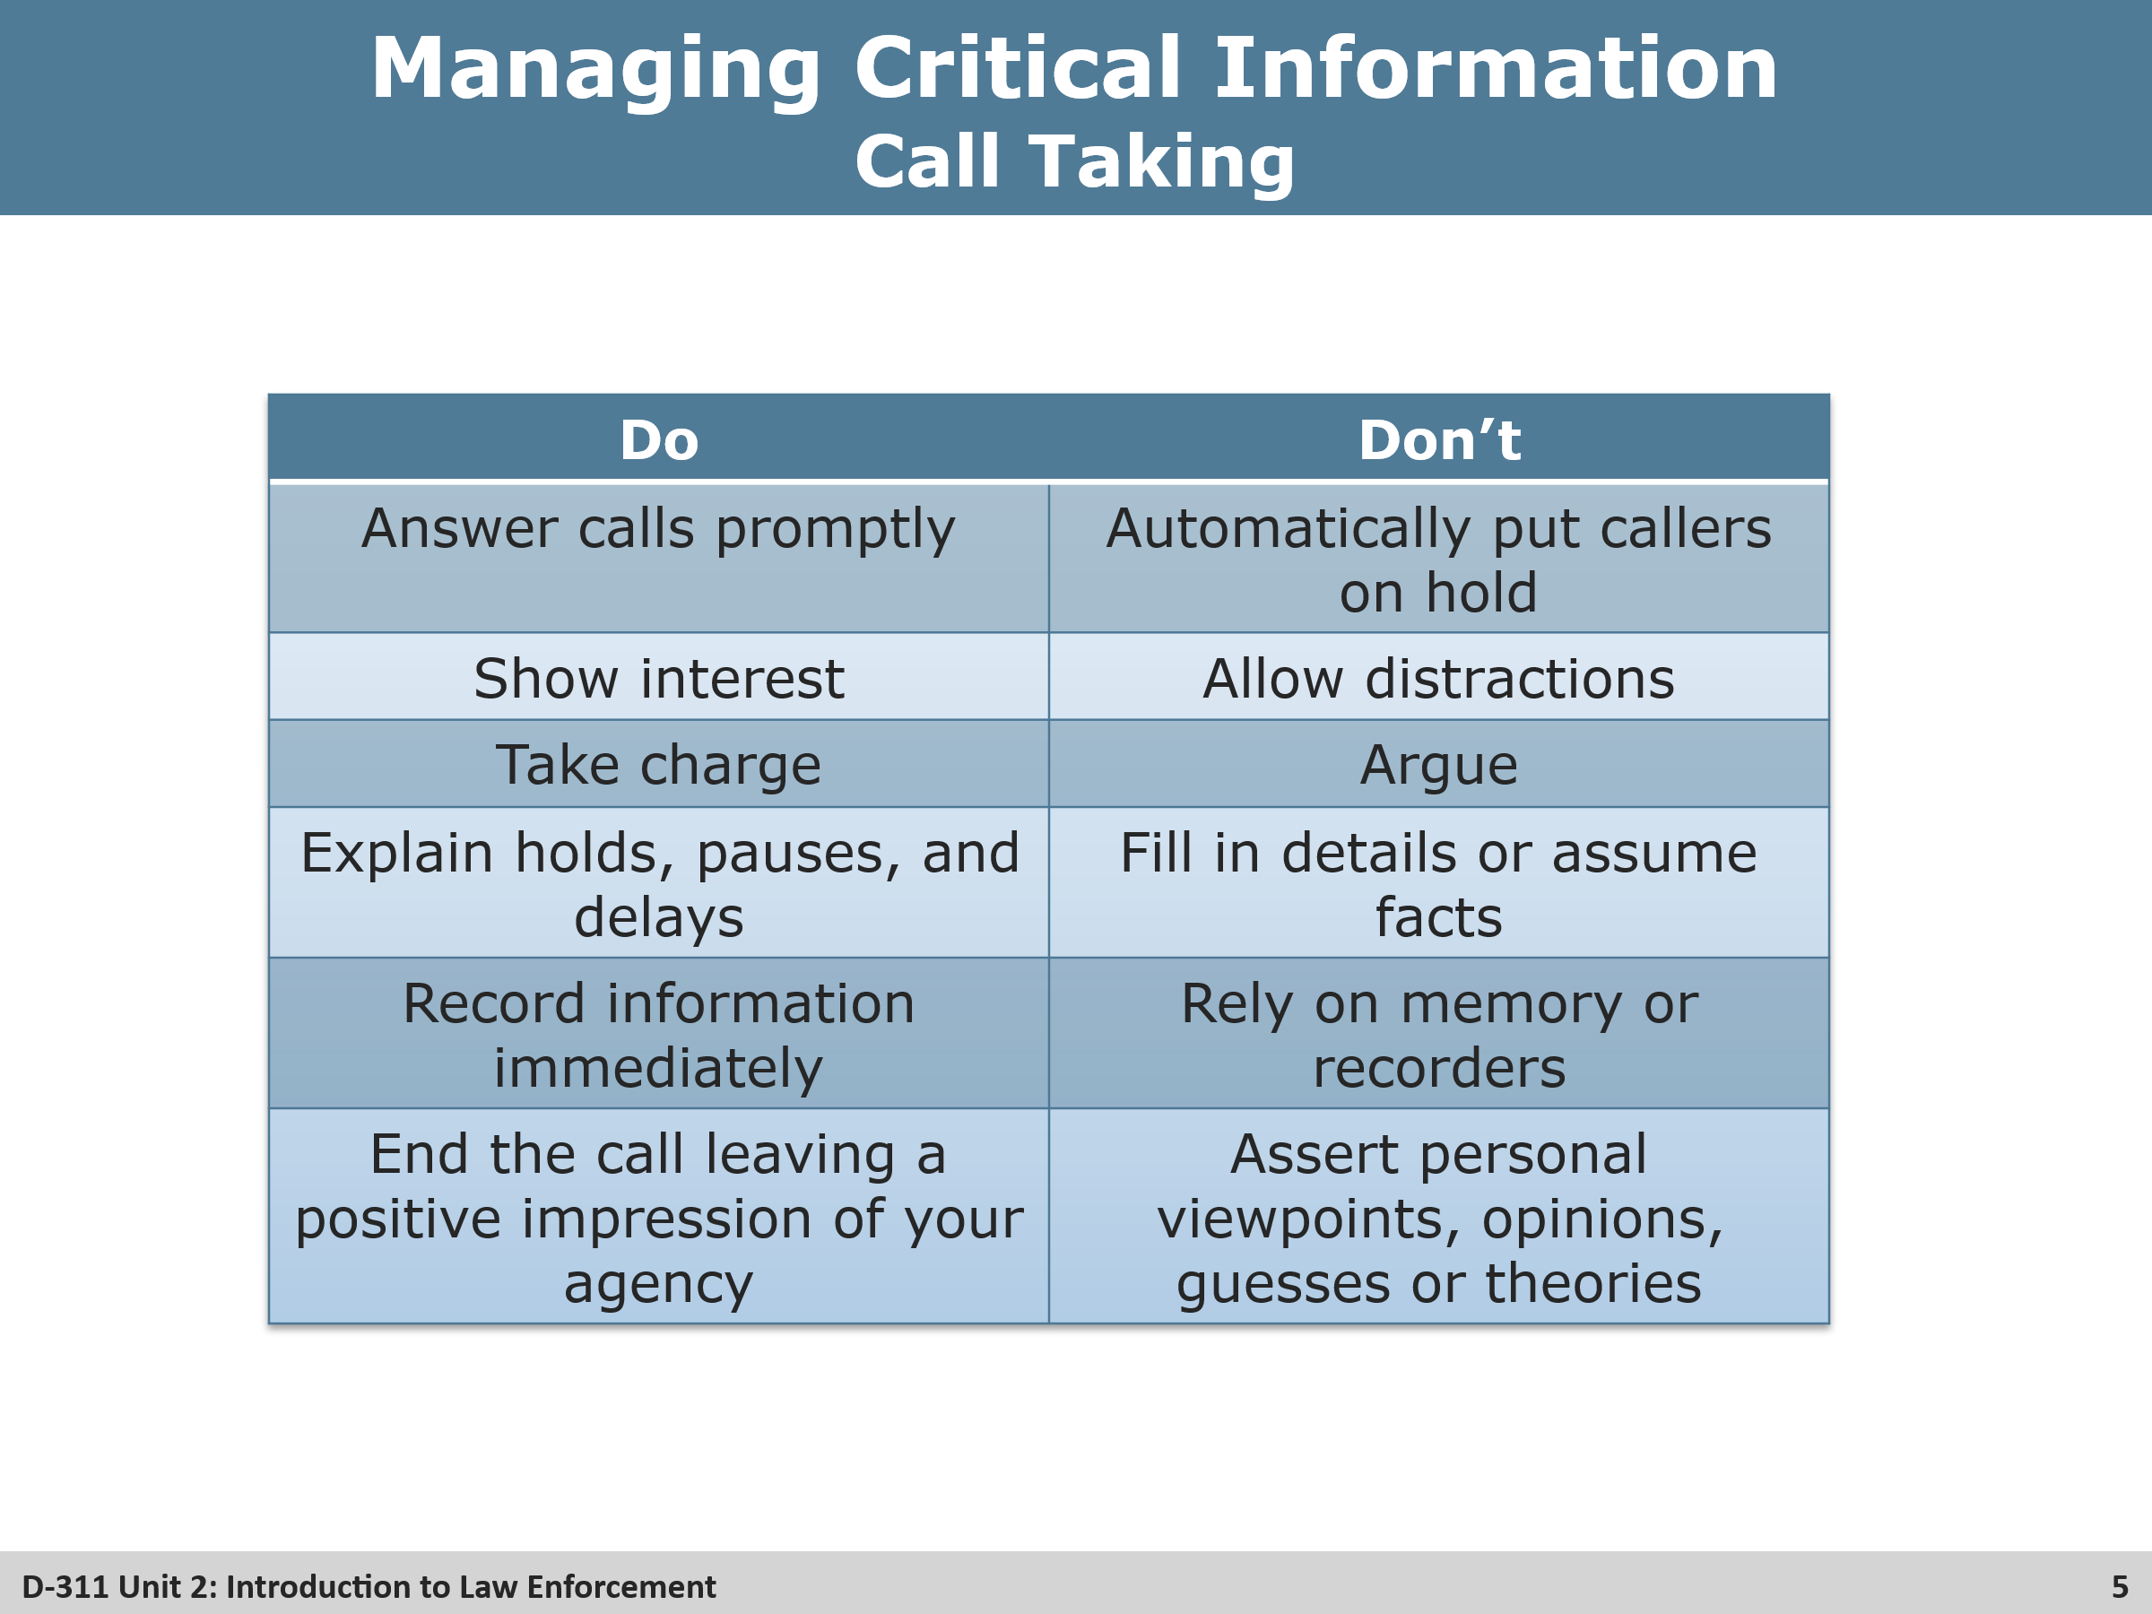

Group Discussion
- Interact with the students to come up with some other do’s or don’ts that may apply.

Slide 6 Gathering Pertinent Details
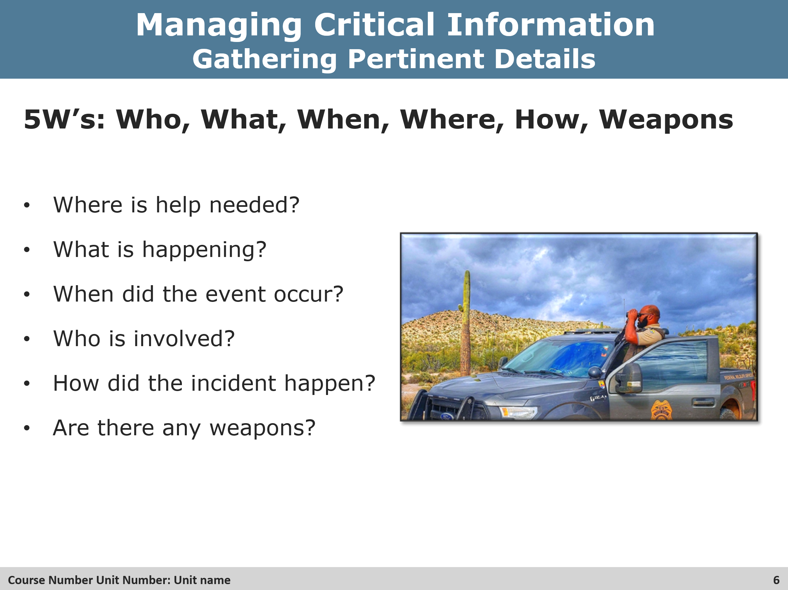
Review
- Explain to the students why these are important.
- Ask the students if they can think of any other details they should ask for.

Slide 7 Descriptive Information
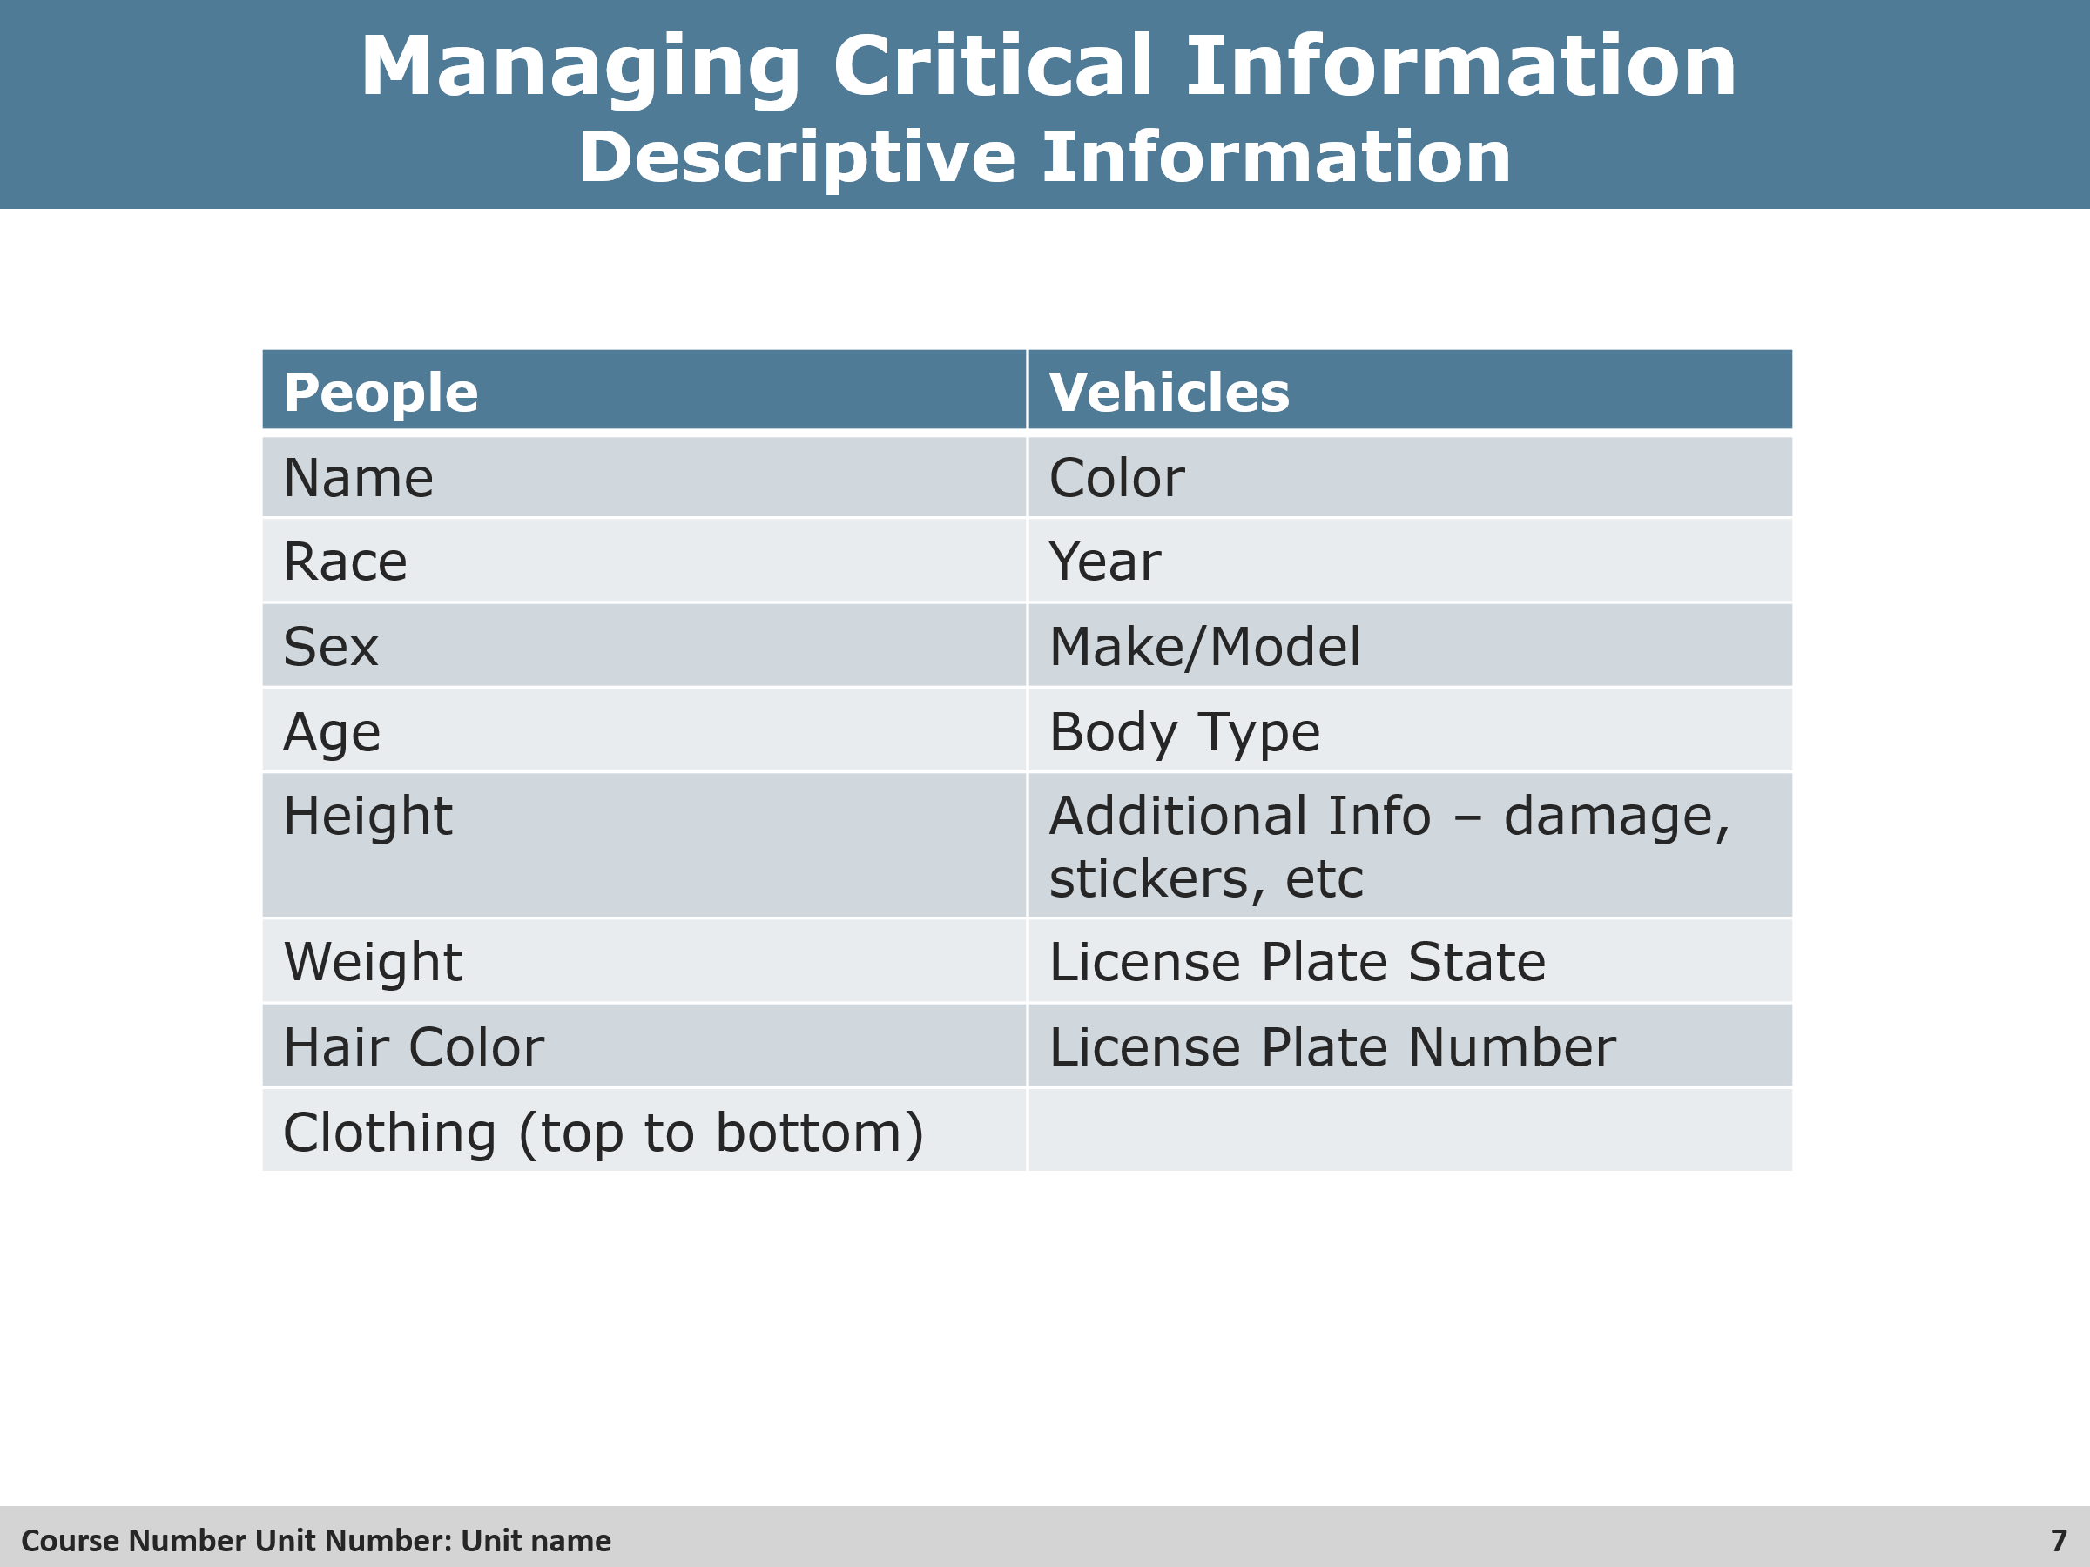
Group Discussion
- Ask the students why this important and who else could be sharing this information with.

Slide 8 Why It’s Important
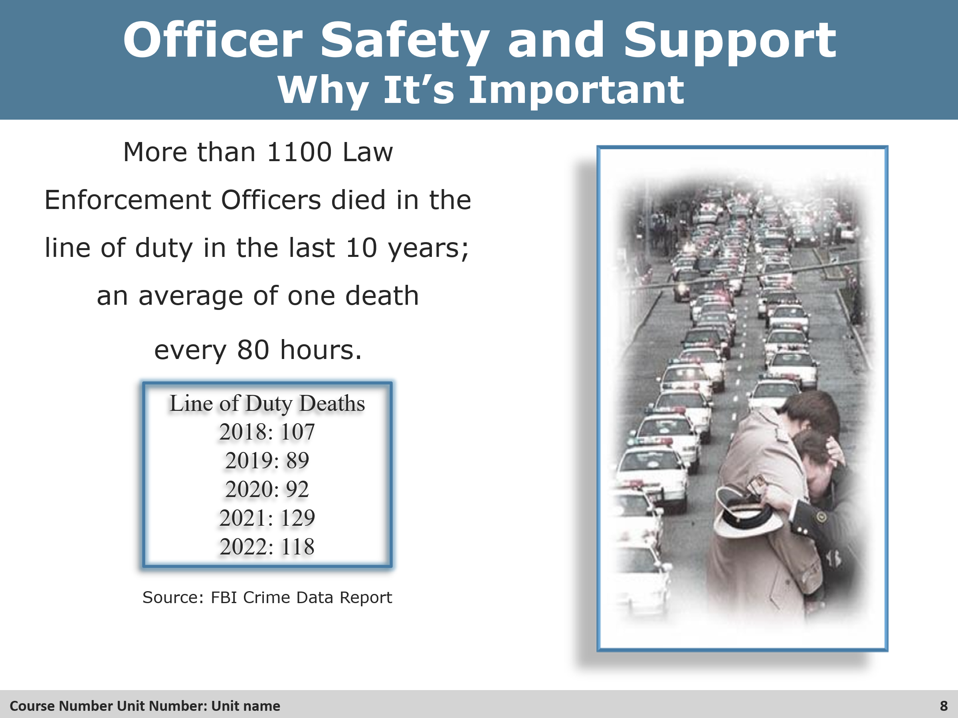
Review
- Explain to the students why this is important and how critical dispatch is to the law enforcement community.

Slide 9 Daily Patrol
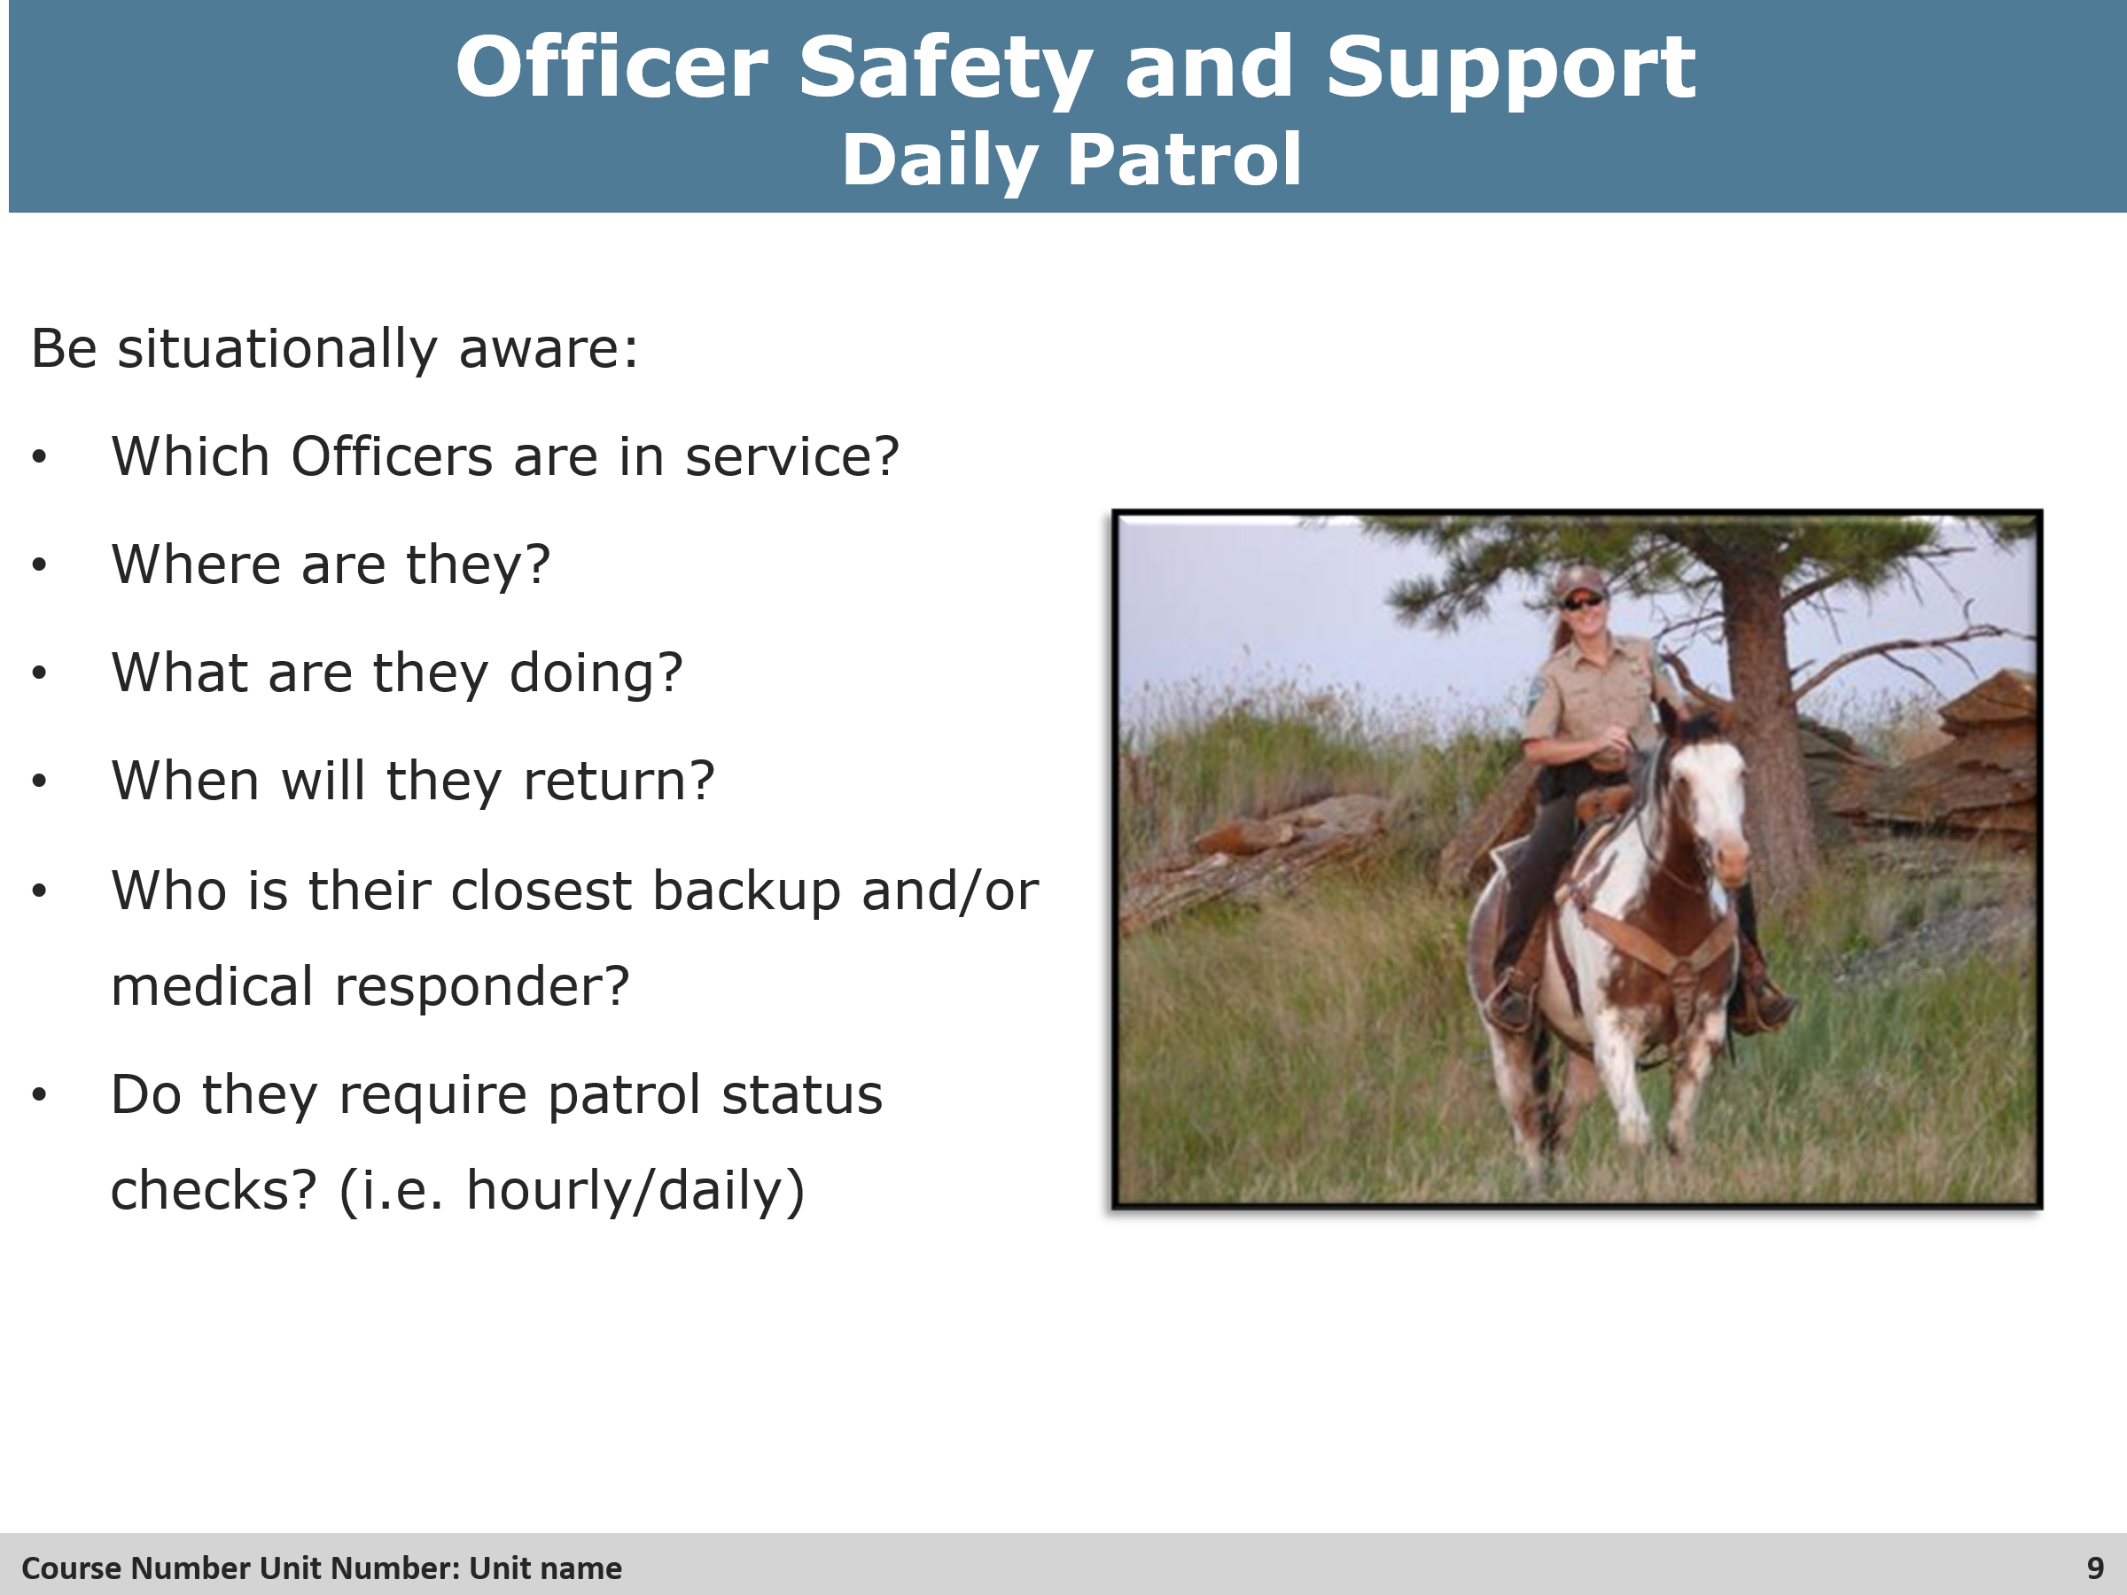
Group Discussion
- Discuss each and go into detail with the students.
    - Why are these important to know
    - Could their closest backup be a local sheriff or other law enforcement agency, etc?

Slide 10 Contacts / Traffics Stops
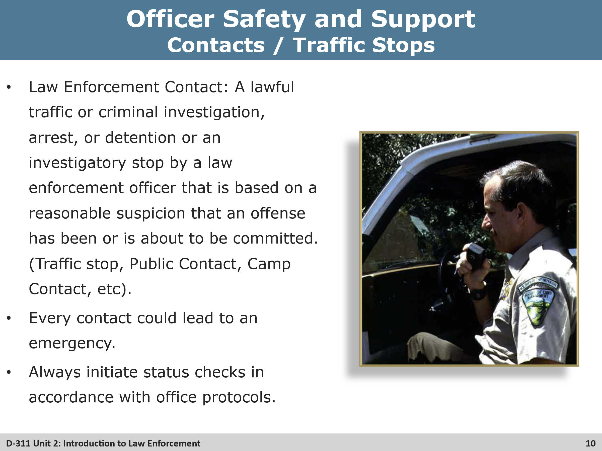
Review
- Review the importance of status checks with the officer.
- How long between status checks?
- What should be done if there is not response from the officer during status checks.

Slides 11 & 12 Prioritizing
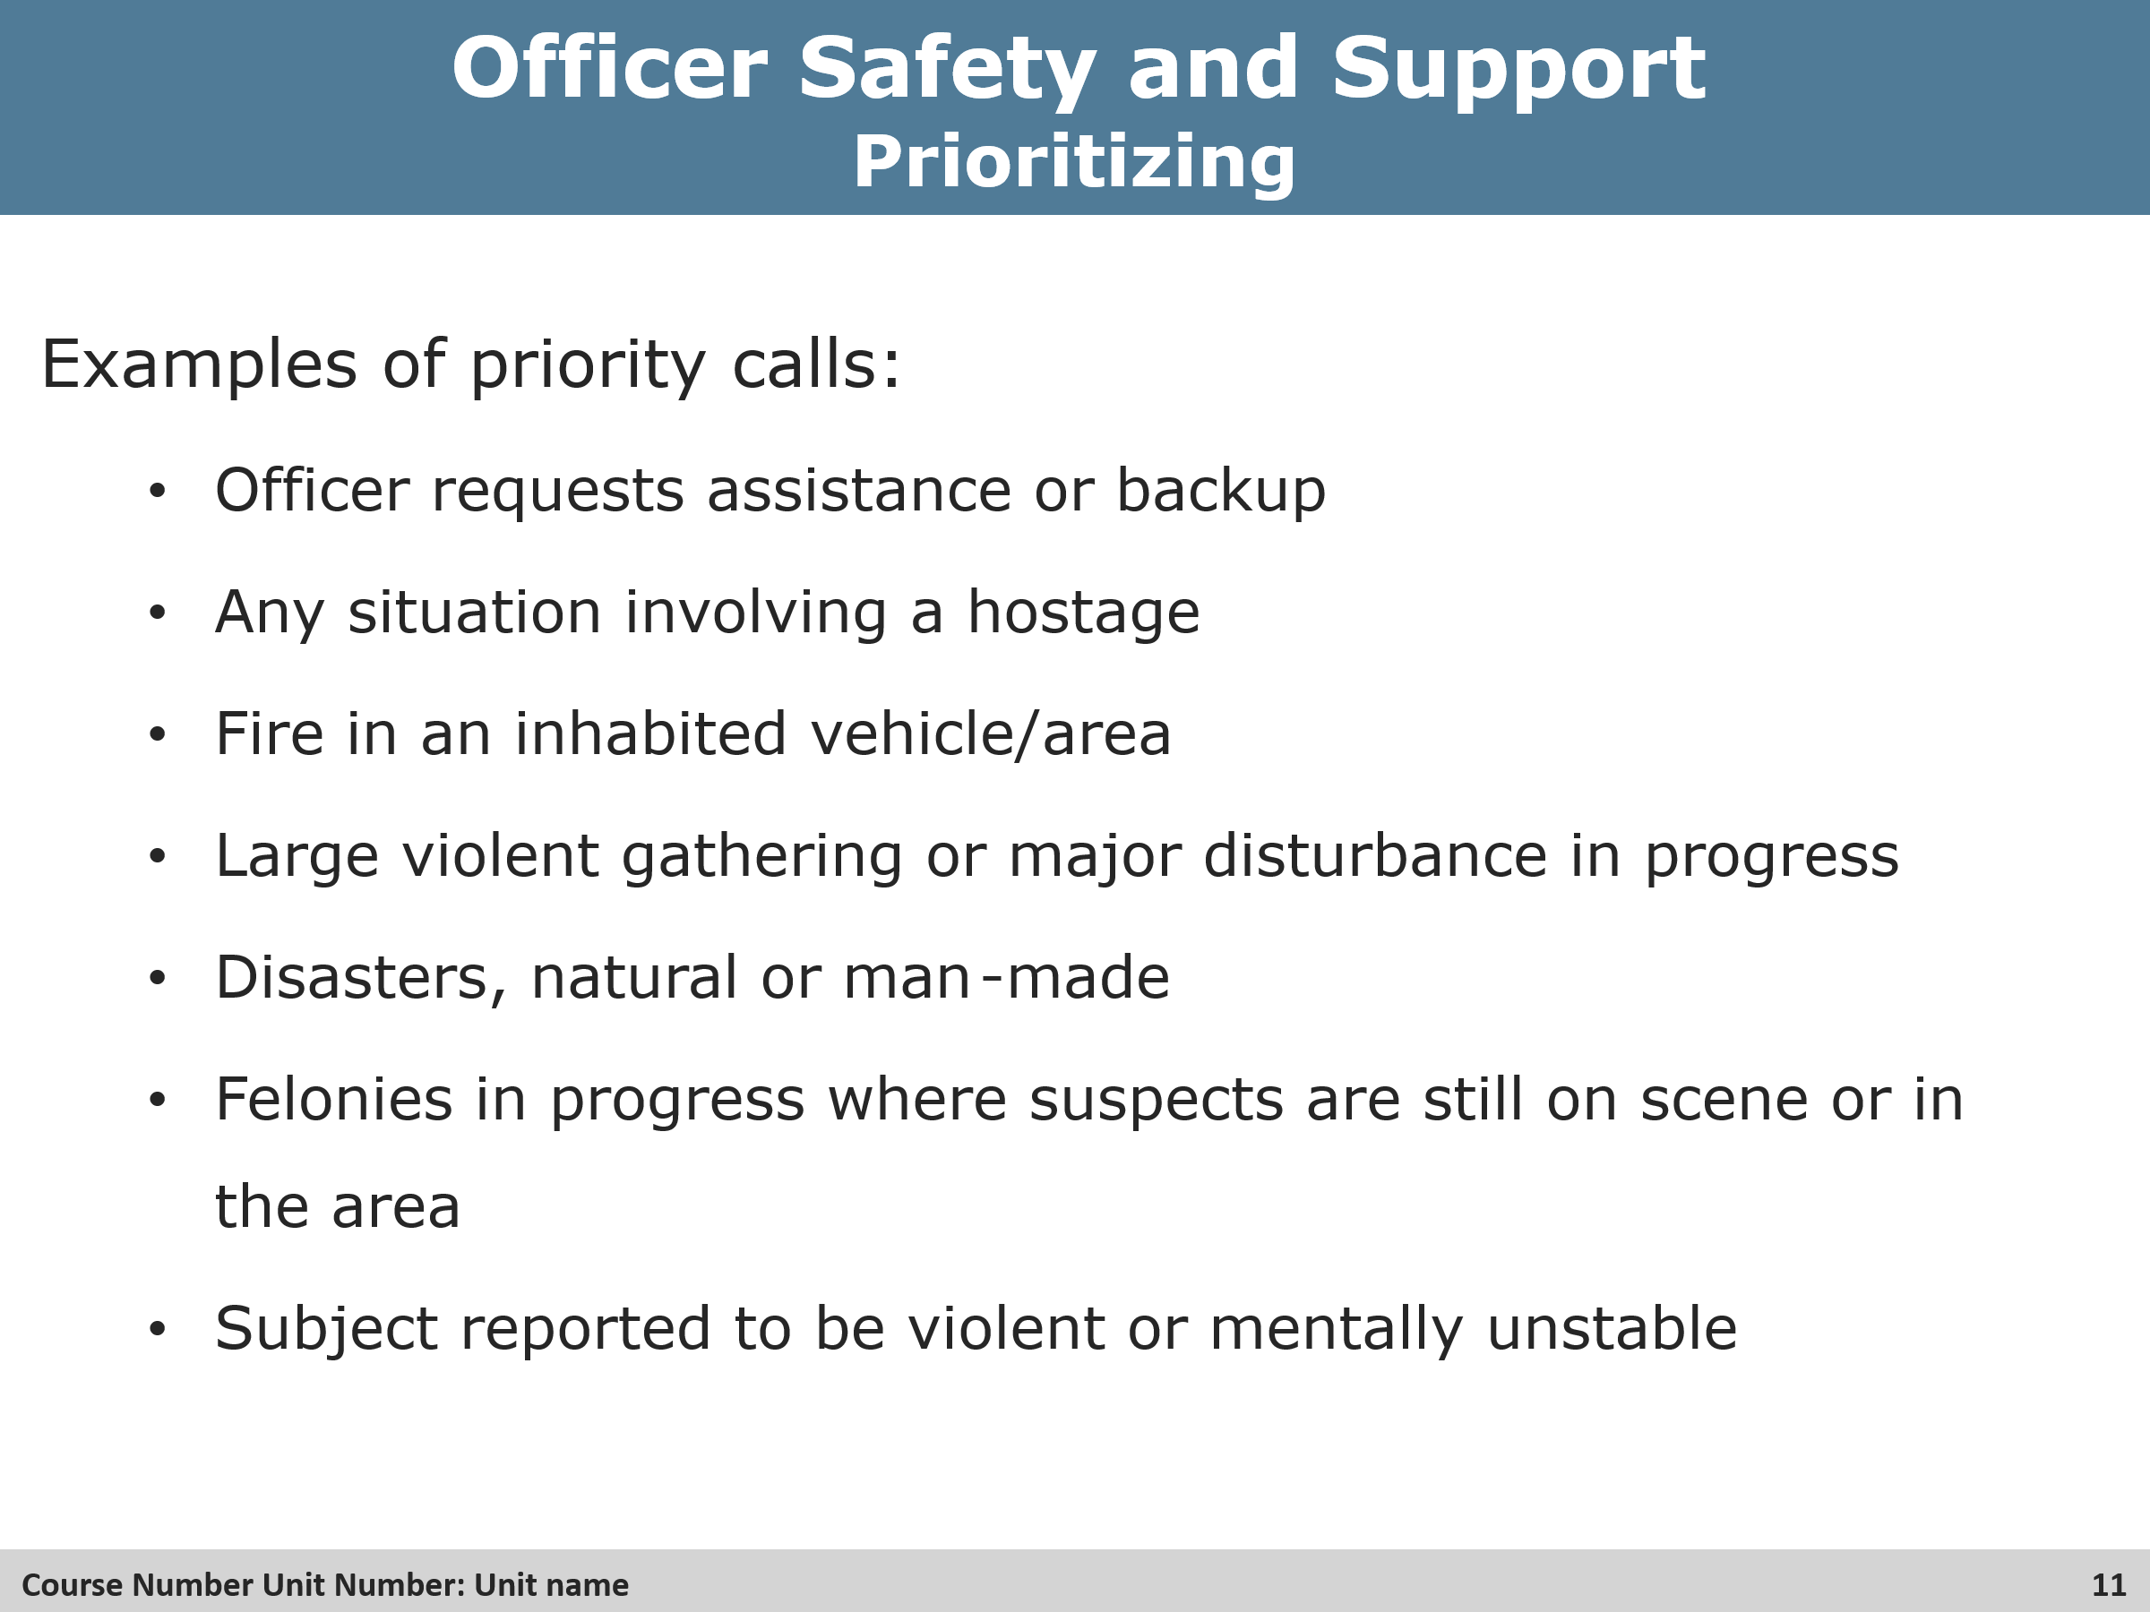
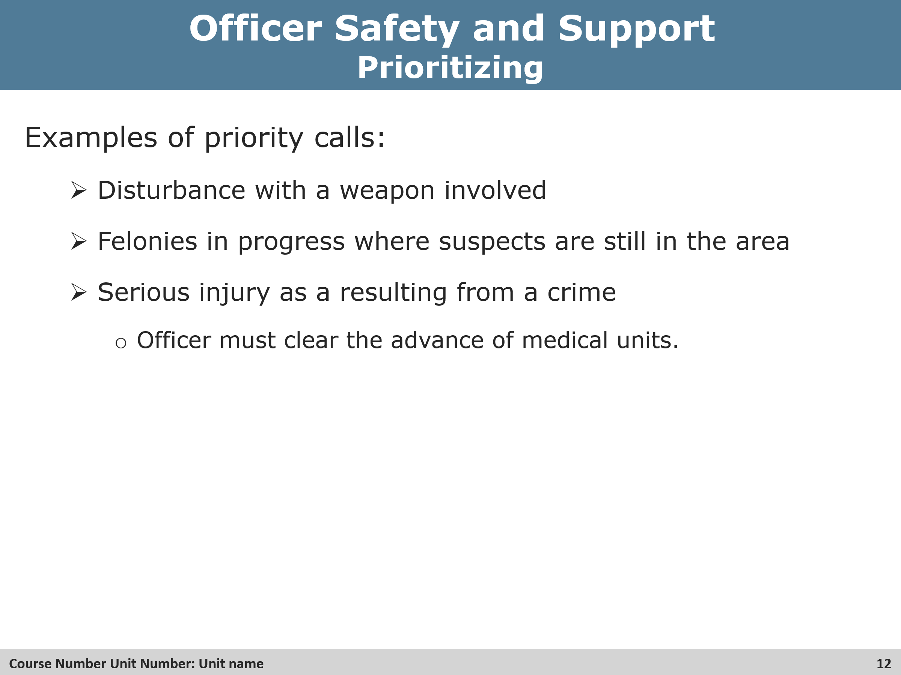
Review
- Review the importance of prioritizing incidents.

Slide 13 Increased Risk Inicdents
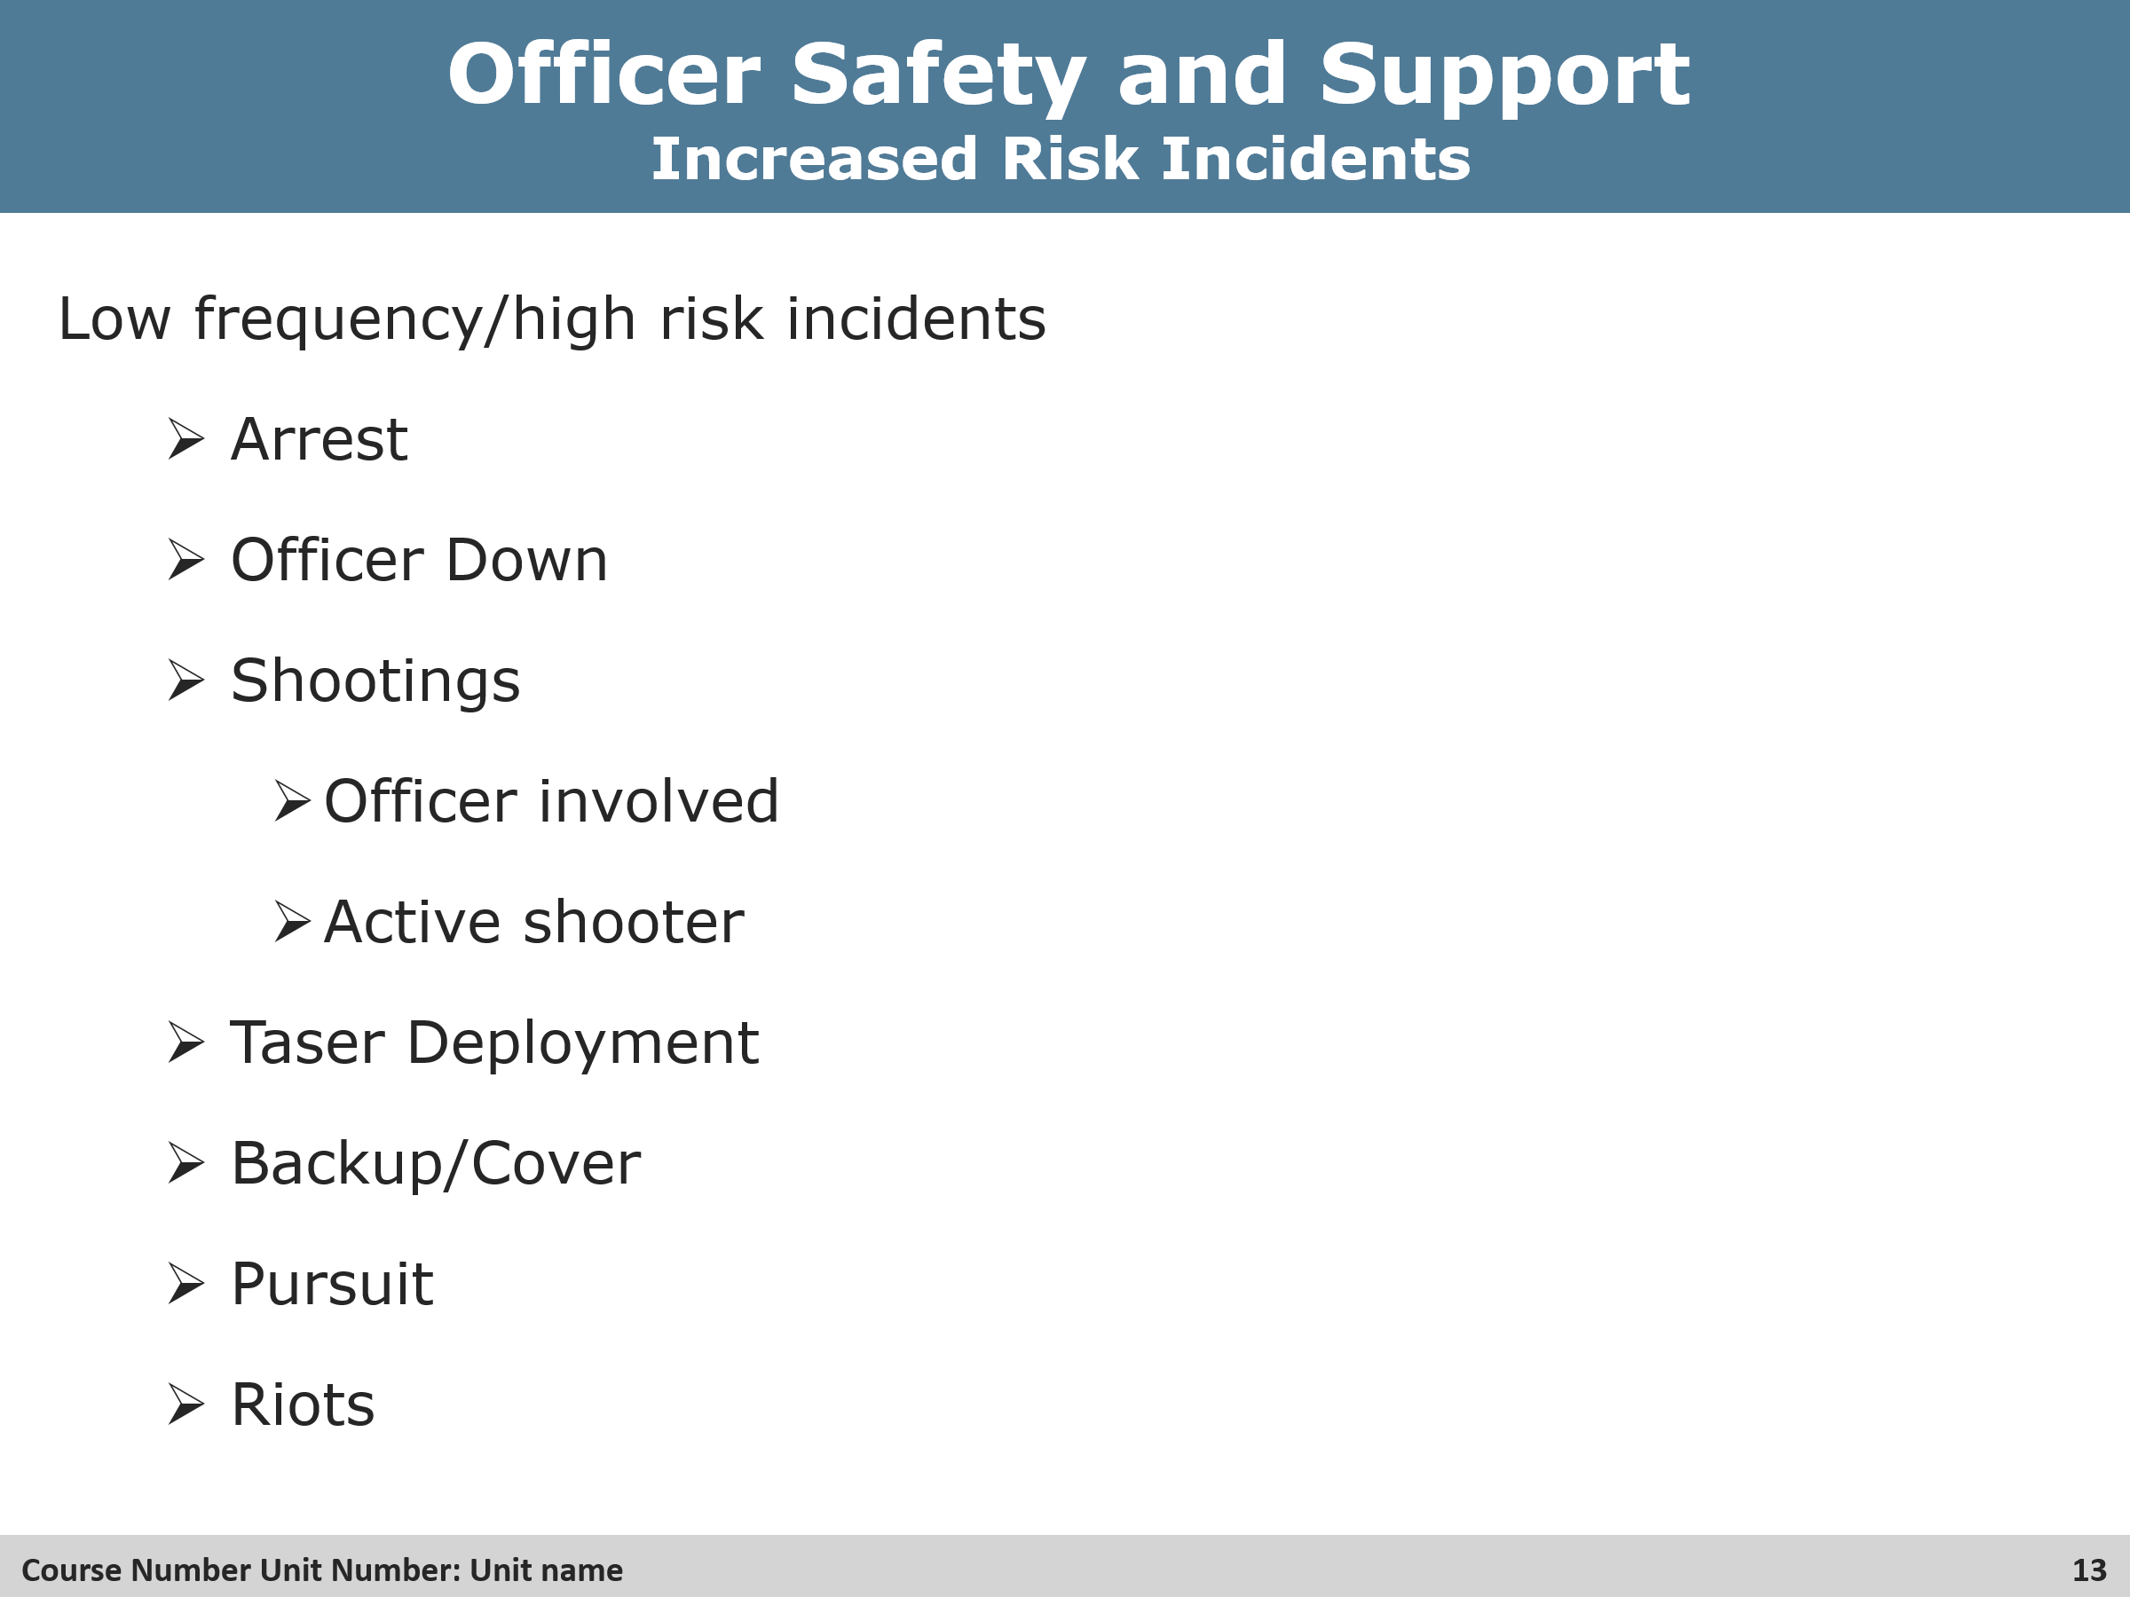
Review
- Review in detail what these incidents could look like.
- Can any of the students come up with any other incidents that may high-risk?

Slides 14 & 15 Contacts / Traffic Stops Cont.
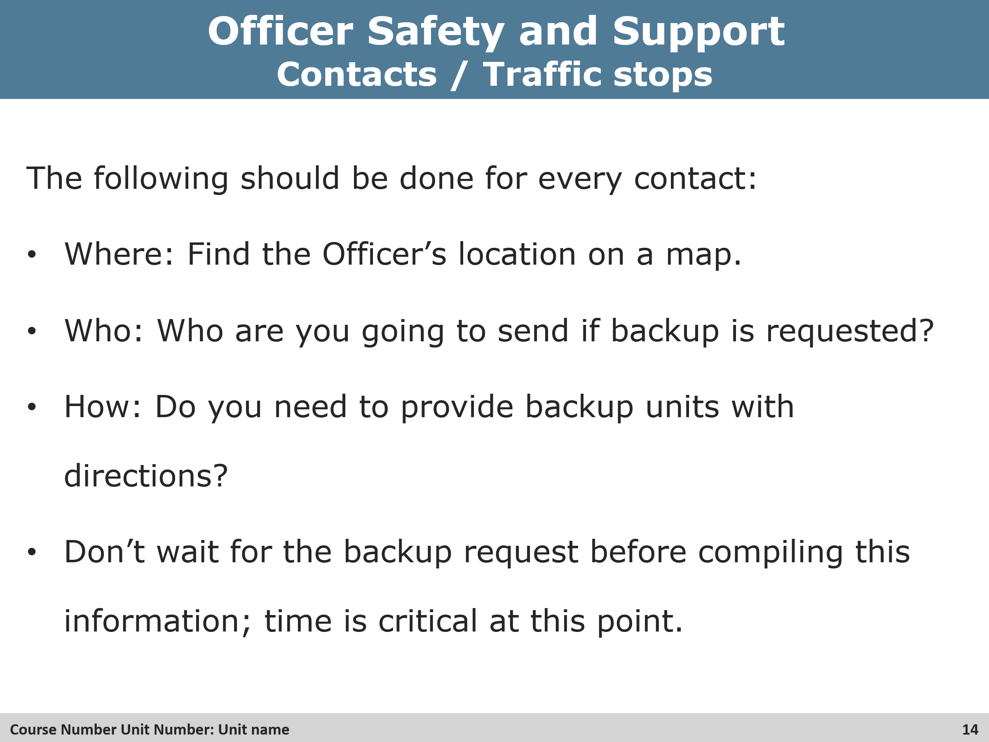
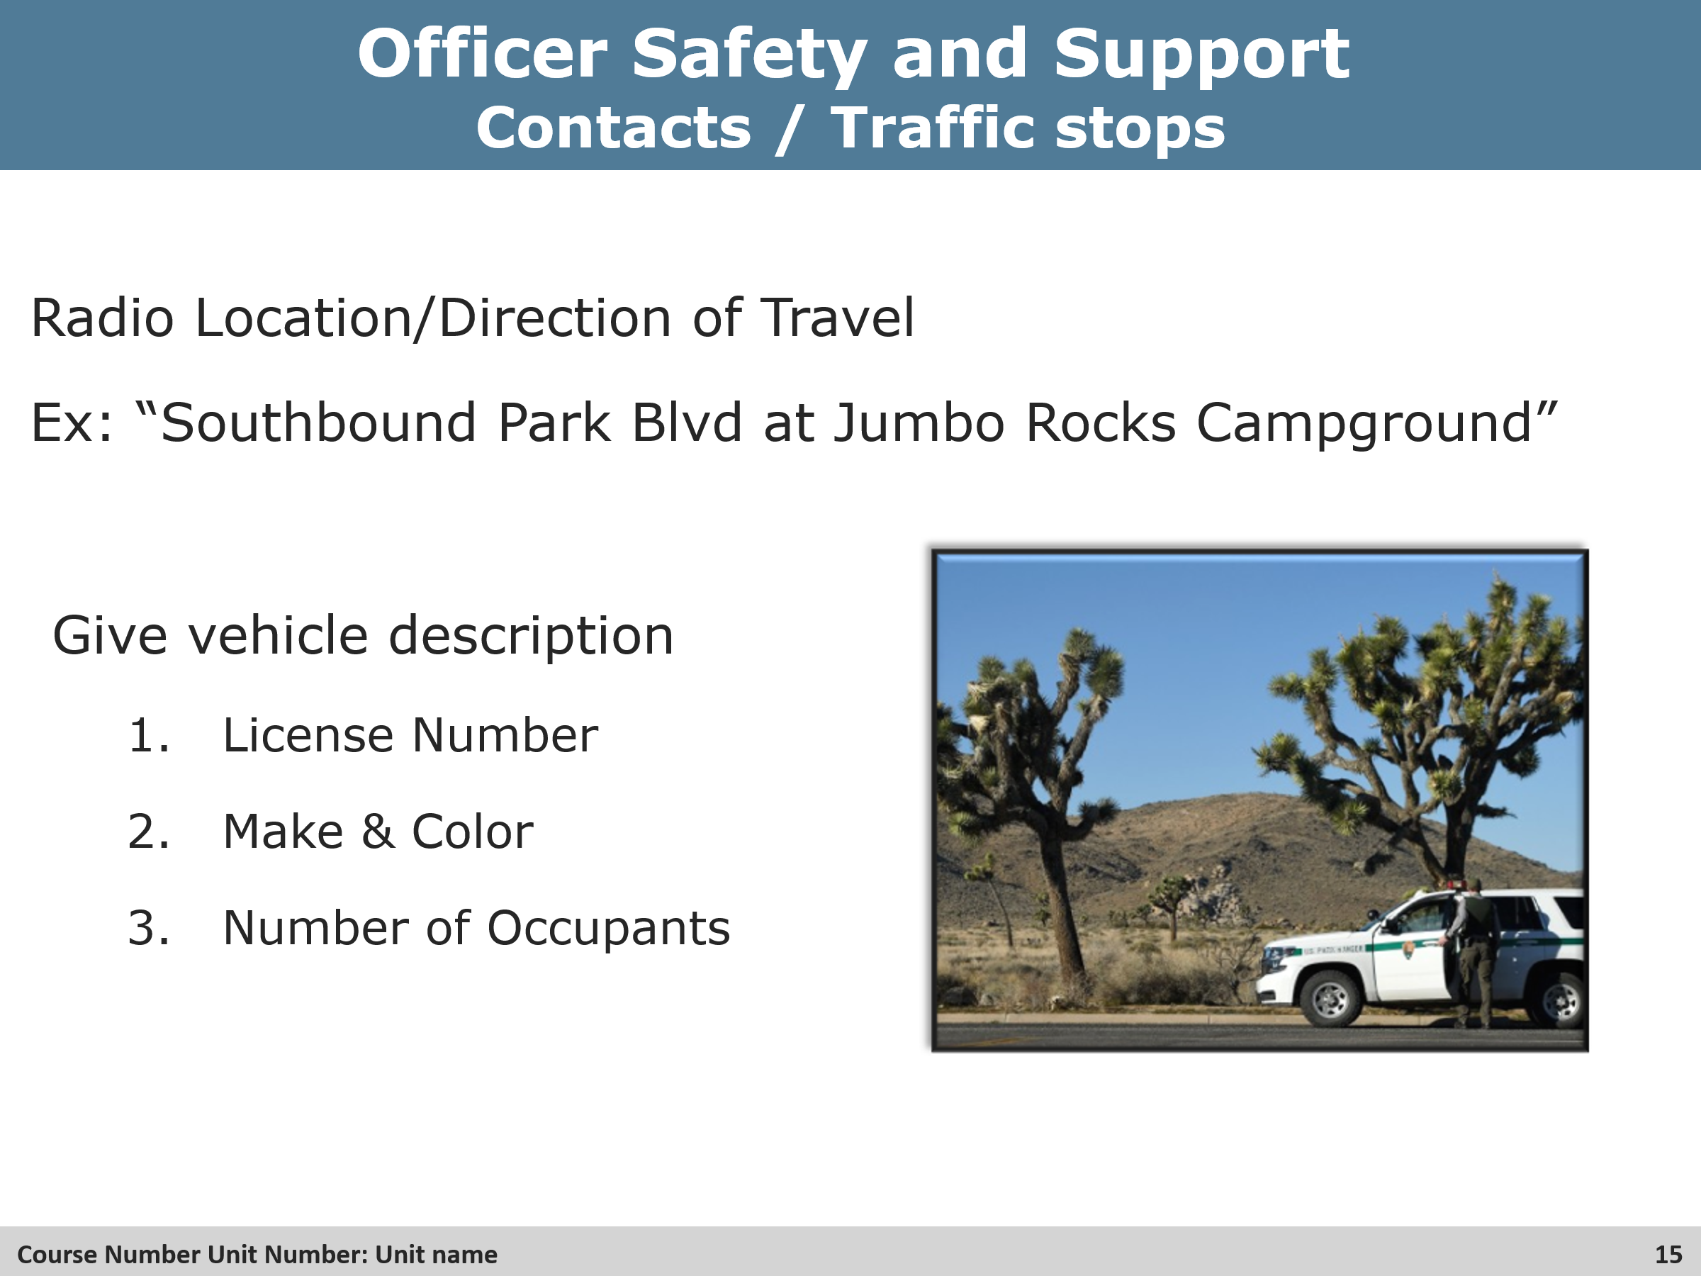
Group Discussion
- Start a group discussion with the students about what other information may be pertinent for these types of incidents.

Slide 16 Contact Status Check
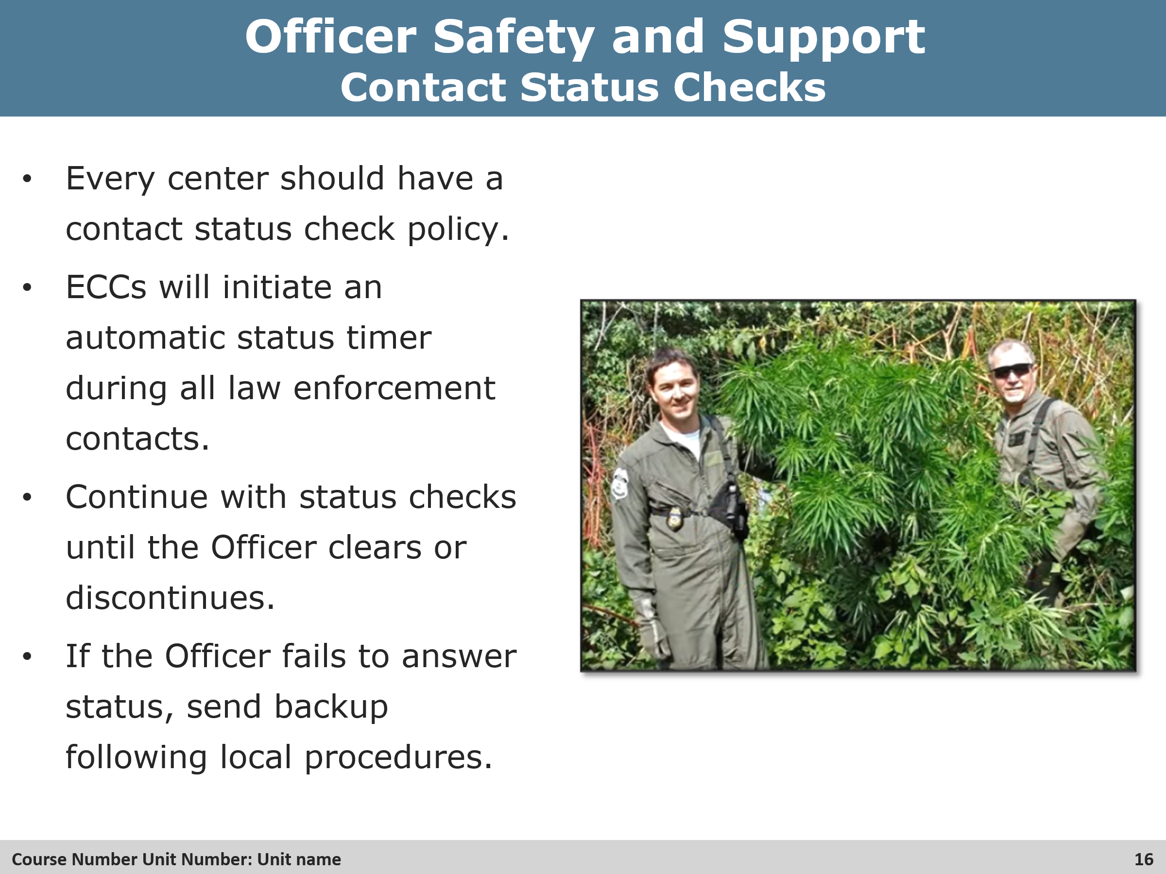
Review
- Again, talk about what typical times in between status checks, i.e. five minutes.
- Talk about what some of local protocols could be for a negative status check, i.e. call other LEOs that may be in the area, contact local sheriff’s office or police department, etc.

Slide 17 Restricting Radio Traffic
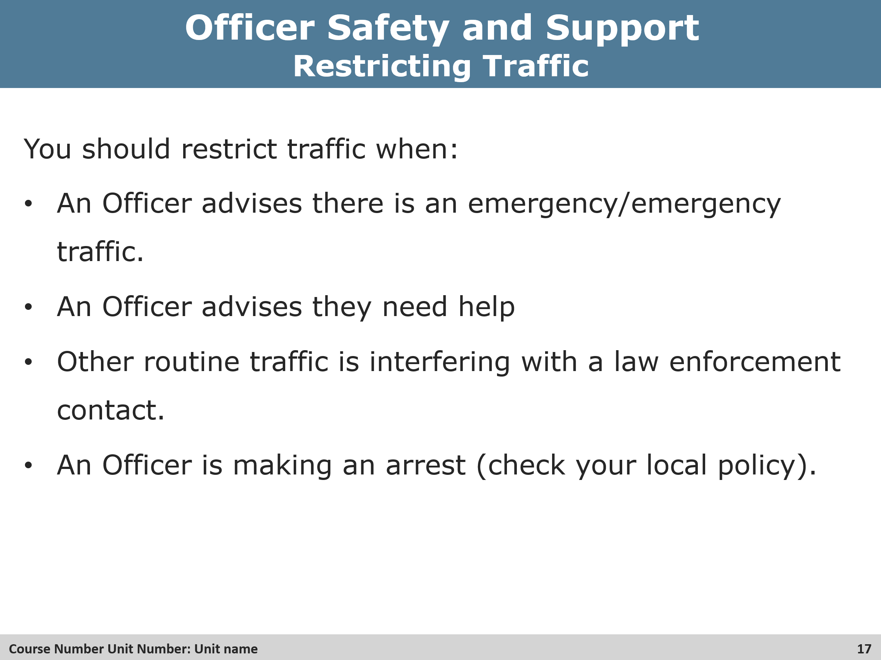
Review
- How should dispatchers restrict radio traffic?
- What should be done if there is more than emergency on a single frequency?
- What has priority, fire or law enforcement?

Exercise
Activity
- Will be the opportunity for the instructor to go through WildCAD with the students for hands on experience with law enforcement incidents.

Slide 25 Objectives Review
